# VISVESVARAYA TECHNOLOGICAL UNIVERSITY

## BELAGAVI – 590018, Karnataka INTERNSHIP REPORT

#### ON

“Virtual Assistant for Visually impaired”

***Submitted in partial fulfilment for the award of degree(18CSI85)***

## BACHELOR OF ENGINEERING IN

## COMPUTER SCIENCE

***Submitted by:***

#### BUDHI VEERA RADHA RANI

#### 1AT19CS028



Conducted at

**COMPSOFT TECHNOLOGIES**



# ATRIA INSTIUTE OF TECHNOLOGY

**Department of COMPUTER SCIENCE**

**Accredited by NBA, New Delhi**

Adjacent Bangalore Baptist Hospital, Hebbal, Bengaluru - 560 024

# ATRIA INSTIUTE OF TECHNOLOGY

**Department of COMPUTER SCIENCE**

**Accredited by NBA, New Delhi**

Adjacent Bangalore Baptist Hospital, Hebbal, Bengaluru - 560 024



**CERTIFICATE**

This is to certify that the Internship titled **“Virtual assistant for visually impaired”** carried out by **Ms BUDHI VEERA RADHA RANI,** a bonafide student of Atria institute of Technology, in partial fulfillment for the award of **Bachelor of Engineering**, in **Computer science** under Visvesvaraya Technological University, Belagavi, during the year 2022-2023. It is certified that all corrections/suggestions indicated have been incorporated in the report.

The project report has been approved as it satisfies the academic requirements in respect of Internship prescribed for the course Internship / Professional Practice (18CSI85)

#### Signature of Guide Signature of HOD Signature of Principal

**External Viva:**

Name of the Examiner Signature with Date

1)

2)

# D E C L A R A T I O N

I, **BUDHI VEERA RADHA RANI**, final year student of computer science, Atria institute of technology - 560 024, declare that the Internship has been successfully completed, in COMPSOFT TECHNOLOGY. This report is submitted in partial fulfillment of the requirements for award of Bachelor Degree in COMPUTER SCIENCE ENGINEERING, during the academic year 2022-2023.

Date :23-09-2022

Place: BANGALORE

USN: 1AT19CS028

NAME: BUDHI VEERA RADHA RANI

**OFFER LETTER**

# A C K N O W L E D G E M E N T

This Internship is a result of accumulated guidance, direction and support of several important persons. We take this opportunity to express our gratitude to all who have helped us to complete the Internship.

We express our sincere thanks to our Principal Dr. T.N Sreenivasa, for providing us adequate facilities to undertake this Internship.

We would like to thank our Head of Dept – Dr.Aishwarya, for providing us an opportunity to carry out Internship and for his valuable guidance and support.

We would like to thank our (Lab Assistant Srinivas) Software Services for guiding us during the period of internship.

We express our deep and profound gratitude to our guide, Guide Pallavi T.P, Assistant/Associate Hanumanthappa H , for her keen interest and encouragement at every step in completing the Internship.

We would like to thank all the faculty members of our department for the support extended during the course of Internship.

We would like to thank the non-teaching members of our dept, forhelping us during the Internship.

Last but not the least, we would like to thank our parents and friends without whose constant help, the completion of Internship would have not been possible.

**BUDHI VEERA RADHA RANI**

**1AT19CS028**

# ABSTRACT

A voice assistant specifically aiming towards aiding the visually imapired.

This system is used to help the visually impaired to have access to the most important features enhancing their living conditions making use of different custom layouts and using speech to text.

More specifically, the system is a chat bot having features solely dedicated towards development of the visually impaired.

The system consist of wearable headphones interfaced to Logitech webcam connected to Raspberry PI.

The system performs tasks based on the input (in form of speech) given by the user and responds back as speech.

# Table of Contents

|  |  |  |
| --- | --- | --- |
| **Sl no** | **Description** | **Page no** |
| 1 | Company Profile | 9-11 |
| 2 | About the Company | 12-14 |
| [3](https://1.bp.blogspot.com/-dODuK8N5h1Q/Wlnyb3V9HFI/AAAAAAAACL4/WxQtCJ1pM5wccDABg4wIrTBUB0vlikXQQCLcBGAs/s1600/poly1.jpg) | Introduction | 15-17 |
| [4](https://1.bp.blogspot.com/-dODuK8N5h1Q/Wlnyb3V9HFI/AAAAAAAACL4/WxQtCJ1pM5wccDABg4wIrTBUB0vlikXQQCLcBGAs/s1600/poly1.jpg) | System Analysis | 18-20 |
| [5](https://1.bp.blogspot.com/-dODuK8N5h1Q/Wlnyb3V9HFI/AAAAAAAACL4/WxQtCJ1pM5wccDABg4wIrTBUB0vlikXQQCLcBGAs/s1600/poly1.jpg) | Requirement Analysis | 20-21 |
| 6 | Design [Analysis](https://4.bp.blogspot.com/-IOOxgPaXMVc/Wlj3LWvcnjI/AAAAAAAACKE/UeTFYvAxDmUDel5UBjdifeWaApB3-dXVgCLcBGAs/s1600/img1.jpg) | 22-23 |
| 7 | [Implementation](https://4.bp.blogspot.com/-IOOxgPaXMVc/Wlj3LWvcnjI/AAAAAAAACKE/UeTFYvAxDmUDel5UBjdifeWaApB3-dXVgCLcBGAs/s1600/img1.jpg) | 24-25 |
| 8 | Snapshots | 26-28 |
| 9 | Conclusion | 29-30 |
| 10 | References | 31 |

**[CHAPTER](https://1.bp.blogspot.com/-dODuK8N5h1Q/Wlnyb3V9HFI/AAAAAAAACL4/WxQtCJ1pM5wccDABg4wIrTBUB0vlikXQQCLcBGAs/s1600/poly1.jpg) 1** **COMPANY PROFILE**

# COMPANY PROFILE

## A Brief History of Compsoft Technologies

Compsoft Technologies, was incorporated with a goal ”To provide high quality and optimal Technological Solutions to business requirements of our clients”. Every business is a different and has a unique business model and so are the technological requirements. They understand this and hence the solutions provided to these requirements are different as well. They focus on clients requirements and provide them with tailor made technological solutions. They also understand that Reach of their Product to its targeted market or the automation of the existing process into e-client and simple process are the key features that our clients desire from Technological Solution they are looking for and these are the features that we focus on while designing the solutions for their clients.

Sarvamoola Software Services. is a Technology Organization providing solutions for all web design and development, MYSQL, PYTHON Programming, HTML, CSS, ASP.NET and LINQ. Meeting the ever increasing automation requirements, Sarvamoola Software Services. specialize in ERP, Connectivity, SEO Services, Conference Management, effective web promotion and tailor-made software products, designing solutions best suiting clients requirements.

Compsoft Technologies, strive to be the front runner in creativity and innovation in software development through their well-researched expertise and establish it as an out of the box software development company in Bangalore, India. As a software development company, they translate this software development expertise into value for their customers through their professional solutions.

They understand that the best desired output can be achieved only by understanding the clients demand better. Compsoft Technologies work with their clients and help them to defiine their exact solution requirement. Sometimes even they wonder that they have completely redefined their solution or new application requirement during the brainstorming session, and here they position themselves as an IT solutions consulting group comprising of high caliber consultants.

They believe that Technology when used properly can help any business to scale and achieve new heights of success. It helps Improve its efficiency, profitability, reliability; to put it in one sentence ” Technology helps you to Delight your Customers” and that is what we want to achieve.

# [CHAPTER](https://1.bp.blogspot.com/-dODuK8N5h1Q/Wlnyb3V9HFI/AAAAAAAACL4/WxQtCJ1pM5wccDABg4wIrTBUB0vlikXQQCLcBGAs/s1600/poly1.jpg) 2 ABOUT THE COMPANY

1. **ABOUT THE COMPANY**



Compsoft Technologies is a Technology Organization providing solutions for all web design and development, MYSQL, PYTHON Programming, HTML, CSS, ASP.NET and LINQ. Meeting the ever increasing automation requirements, Compsoft Technologies specialize in ERP, Connectivity, SEO Services, Conference Management, effective web promotion and tailor-made software products, designing solutions best suiting clients requirements. The organization where they have a right mix of professionals as a stakeholders to help us serve our clients with best of our capability and with at par industry standards. They have young, enthusiastic, passionate and creative Professionals to develop technological innovations in the field of Mobile technologies, Web applications as well as Business and Enterprise solution. Motto of our organization is to “Collaborate with our clients to provide them with best Technological solution hence creating Good Present and Better Future for our client which will bring a cascading a positive effect in their business shape as well”. Providing a Complete suite of technical solutions is not just our tag line, it is Our Vision for Our Clients and for Us, We strive hard to achieve it.

## Products of Compsoft Technologies.

**Android Apps**

It is the process by which new applications are created for devices running the Android operating system. Applications are usually developed in Java (and/or Kotlin; or other such option) programming language using the Android software development kit (SDK), but other development environments are also available, some such as Kotlin support the exact same Android APIs (and bytecode), while others such as Go have restricted API access.

The Android software development kit includes a comprehensive set of development tools. These include a debugger, libraries, a handset emulator based on QEMU, documentation, sample code, and zutorials. Currently supported development platforms include computers running Linux (any modern desktop Linux distribution), Mac OS X 10.5.8 or later, and Windows 7 or later. As of March 2015, the SDK is not available on Android itself, but softwaredevelopment is possible by using specialized Android applications.

**Web Application**

It is a client–server computer program in which the client (including the user interface and client- side logic) runs in a web browser. Common web applications include web mail, online

retail sales, online auctions, wikis, instant messaging services and many other functions. web applications use web documents written in a standard format such as HTML and JavaScript,which are supported by a variety of web browsers. Web applications can be considered as a specifific variant of client–server software where the client software is downloaded to the client machine when visiting the relevant web page, using standard procedures such as HTTP. The Client web software updates may happen each time the web page is visited. During the session, the web browser interprets and displays the pages, and acts as the universal client for any web application. The use of web application frameworks can often reduce the number of errors in a program, both by making the code simpler, and by allowing one team to concentrate on the framework while another focuses on a specifified use case. In applications which are exposed to constant hacking attempts on the Internet, security- related problems can be caused by errors in the program.

Frameworks can also promote the use of best practices such as GET after POST. There are some who view a web application as a two-tier architecture. This can be a “smart” client that performs all the work and queries a “dumb” server, or a “dumb” client that relies on a “smart” server. The client would handle the presentation tier, the server would have the database (storage tier), and the business logic (application tier) would be on one of them or on both. While this increases the scalability of the applications and separates the display and the database, it still doesn‟t allow for true specialization of layers, so most applications will outgrow this model. An emerging strategy for application software companies is to provide web access to software previously distributed as local applications. Depending on the type of application, it may require the development of an entirely different browser-based interface, or merely adapting an existing application to use different presentation technology. These programs allow the user to pay a monthly or yearly fee for use of a software application without having to install it on a local hard drive. A company which follows this strategy is known as an application service provider (ASP), and ASPs are currently receiving much attention in the software industry.

Security breaches on these kinds of applications are a major concern because it can involve both enterprise information and private customer data. Protecting these assets is an important part of any web application and there are some key operational areas that must be included in the development process. This includes processes for authentication, authorization, asset handling, input, and logging and auditing. Building security into the applications from the beginning can be more effective and less disruptive in the long run.

**Web design**

It is encompasses many different skills and disciplines in the production and maintenance of websites. The different areas of web design include web graphic design; interface design; authoring, including standardized code and proprietary software; user experience design; and

search engine optimization. The term web design is normally used to describe the design process relating to the front-end (client side) design of a website including writing mark up. Web design partially overlaps web engineering in the broader scope of web development. Web designers are expected to have an awareness of usability and if their role involves creating mark up then they are also expected to be up to date with web accessibility guidelines. Web design partially overlaps web engineering in the broader scope of web development.

## Departments and services offered

Compsoft Technologies plays an essential role as an institute, the level of education, development of student’s skills are based on their trainers. If you do not have a good mentor then you may lag in many things from others and that is why we at Compsoft Technologies gives you the facility of skilled employees so that you do not feel unsecured about the academics. Personality development and academic status are some of those things which lie on mentor’s hands. If you are trained well then you can do well in your future and knowing its importance of Compsoft Technologies always tries to give you the best.

They have a great team of skilled mentors who are always ready to direct their trainees in the best possible way they can and to ensure the skills of mentors we held many skill development programs as well so that each and every mentor can develop their own skills with the demands of the companies so that they can prepare a complete packaged trainee.

## Services provided by Compsoft Technologies.

* Core Java and Advanced Java
* Web services and development
* Dot Net Framework
* Python
* Selenium Testing
* Conference / Event Management Service
* Academic Project Guidance
* On The Job Training
* Software Training

# [CHAPTER](https://1.bp.blogspot.com/-dODuK8N5h1Q/Wlnyb3V9HFI/AAAAAAAACL4/WxQtCJ1pM5wccDABg4wIrTBUB0vlikXQQCLcBGAs/s1600/poly1.jpg) 3 INTRODUCTION

1. **INTRODUCTION**

## Introduction to ML

## Virtual assistant is employed to run machine like laptop or PC’s on your own command. Virtual assistant is an application program that acknowledges natural language and voice commands to finish tasks for the users. Virtual Assistant are completely software package based but nowadays they’re integrated in numerous devices and additionally a number of the assistants are designed explicitly for single devices like Alexa. Due to forceful amendment in technology now it’s a high time to train our machine with the assistance of machine learning, deep learning, neural networks. Today we are able to talk to our machine with the help of Voice Assistant. Today every huge company is using Voice Assistant so that their user will take the assistance of machine through their voice. So, with the Voice Assistant we are moving to the consecutive level advancement where we are able to talk to our machine. Dr. Kshama V. Kulhalli (2017) et al. proposed the Most famous application of iPhone is “SIRI” that helps the end user to connect end user mobile with voice and it additionally responds to the voice commands of the user.The earliest makes an attempts to plan systems for automatic speech recognition by machine were created in the 1950’s, when various researchers tried to exploit the fundamental ideas of acoustic-phonetics. In 1952, at Bell Laboratories, Davis, Biddulph, and Balashek engineered a system for isolated digit recognition for a single speaker.

## Problem Statement

We aim to develop a system/assistant that will **serve to guide a visually impaired person and will indicate the person by speaking through the earpiece**. The system will help the person recognize people, add new faces and detect objects that are in their vicinity.

# [CHAPTER](https://1.bp.blogspot.com/-dODuK8N5h1Q/Wlnyb3V9HFI/AAAAAAAACL4/WxQtCJ1pM5wccDABg4wIrTBUB0vlikXQQCLcBGAs/s1600/poly1.jpg) 4 SYSTEM ANALYSIS

**4. SYSTEM ANALYSIS**

## Existing System

## Proposed System

## As a response to the above-mentioned concern, the researchers proposed a voice assistant application for individuals with visual impairment. The app acts as a voice assistant for visually impaired persons. This is a smart means that allows them to have access to the most important features of their phone. The app will have a custom messaging feature, dialer, call log, notes, and other important features. The system will speak out every action performed by the user to let the user know the actions performed. The app will assist users with reading message contents, taking notes, speaking out the dialed number, and receiving notifications. The app will act as a voice assistant for whatever action the user has performed through a custom app.

## Objective of the System

**General Objective –**The project’s main purpose is to create a voice assistant application that will help visually impaired people access critical phone functionalities and do daily tasks.

# [CHAPTER](https://1.bp.blogspot.com/-dODuK8N5h1Q/Wlnyb3V9HFI/AAAAAAAACL4/WxQtCJ1pM5wccDABg4wIrTBUB0vlikXQQCLcBGAs/s1600/poly1.jpg) 5 REQUIREMENT ANALYSIS

**5. REQUIREMENT ANALYSIS**

## Hardware Requirement Specification

* Processor: Minimum 1 GHz; Recommended 2GHz or more.
* Ethernet connection (LAN) OR a wireless adapter (Wi-Fi)
* Hard Drive: Minimum 32 GB; Recommended 64 GB or more.
* Memory (RAM): Minimum 1 GB; Recommended 4 GB or above.
* Sound card w/speakers.
* Some classes require a camera and microphone.

## Software Requirement Specification

1. SpeechRecognizer, Google API for speech to text conversion

2. Python Text to Speech https://pypi.org/project/pyttsx3/

3. Object Recogniiton using *COCO Dataset*

4. Google Cloud Vision API

5. Dialogflow

# [CHAPTER](https://1.bp.blogspot.com/-dODuK8N5h1Q/Wlnyb3V9HFI/AAAAAAAACL4/WxQtCJ1pM5wccDABg4wIrTBUB0vlikXQQCLcBGAs/s1600/poly1.jpg) 6 DESIGN ANALYSIS

1. **DESIGN & ANALYSIS**

The system is deployed as a web application which, when opened on any mobile browser, gives us the landing page shown below. Along with the landing page, we have two additional pages that play an important role in our system and play a fundamental role in its deployment. When the user presses any of these buttons, the command will be addressed to the user via earpiece/speaker. All these buttons are large in size and are separated properly, so that it is convenient for the visually impaired user to distinguish between them. This page consists of two buttons- one at the top and the other at the bottom of the page. We have a block in the center of the page which provides a continuous live stream that is displayed through the phone. Above the block is the "SWITCH TO FACE RECOGNITION" button which, when clicked, deploys the Face recognition model and directs the user to that page. The other button is named "STOP" and resides below the live stream block. When clicked, this button will stop the current processing model and redirect the user to the page having the "START" button.

A click on the "SWITCH TO FACE RECOGNITION" button, the system is directed to a new page where the face recognition functionality begins its execution. Similar to the landing page, this page consists of two buttons- one at the top and the other at the bottom of the page. The button at the top is named "ADD FACE" whilst the button at the bottom of the page is named "STOP". If an unknown face is encountered, we can click on the "ADD FACE' button at the top of the page to add the unknown face into the Facial database. The "STOP" button executes the same functionality as before and will stop the current processing model and redirect the user to the page where the "START" button resides. The block in the center of the page separates the two buttons and continues to provide the live stream and displays it through the phone's browser window. All the faces recognized in the live stream are addressed to the user via earpiece/speaker. This page consists of a single large button named "START”. When the "STOP" button on either of the Face Recognition page or the Object Detection page is clicked, the user is redirected to this page where the "START" button resides.This enables the user to start the system anew after it has been stopped. Hence, allowing the user to begin the system according to their convenience and usability.

# [CHAPTE](https://1.bp.blogspot.com/-dODuK8N5h1Q/Wlnyb3V9HFI/AAAAAAAACL4/WxQtCJ1pM5wccDABg4wIrTBUB0vlikXQQCLcBGAs/s1600/poly1.jpg)R 7 IMPLEMENTATION

1. **IMPLEMENTATION**

Implementation is the stage where the theoretical design is turned into a working system. The most crucial stage in achieving a new successful system and in giving confidence on the new system for the users that it will work efficiently and effectively.

The system can be implemented only after thorough testing is done and if it is found to work according to the specification. It involves careful planning, investigation of the current system and it constraints on implementation, design of methods to achieve the change over and an evaluation of change over methods a part from planning.

Two major tasks of preparing the implementation are education and training of the users and testing of the system. The more complex the system being implemented, the more involved will be the system analysis and design effort required just for implementation.

The implementation phase comprises of several activities. The required hardware and software acquisition is carried out. The system may require some software to be developed. For this, programs are written and tested. The user then changes over to his new fully tested system and the old system is discontinued.

## TESTING

The testing phase is an important part of software development. It is the Information zed system will help in automate process of finding errors and missing operations and also a complete verification to determine whether the objectives are met and the user requirements are satisfied. Software testing is carried out in three steps:

1. The first includes unit testing, where in each module is tested to provide its correctness, validity and also determine any missing operations and to verify whether the objectives have been met. Errors are noted down and corrected immediately.
2. Unit testing is the important and major part of the project. So errors are rectified easily in particular module and program clarity is increased. In this project entire system is divided into several modules and is developed individually. So unit testing is conducted to individual modules.
3. The second step includes Integration testing. It need not be the case, the software whose modules when run individually and showing perfect results, will also show perfect results when run as a whole.

# [CHAPTE](https://1.bp.blogspot.com/-dODuK8N5h1Q/Wlnyb3V9HFI/AAAAAAAACL4/WxQtCJ1pM5wccDABg4wIrTBUB0vlikXQQCLcBGAs/s1600/poly1.jpg)R 8 SNAPSHOTS

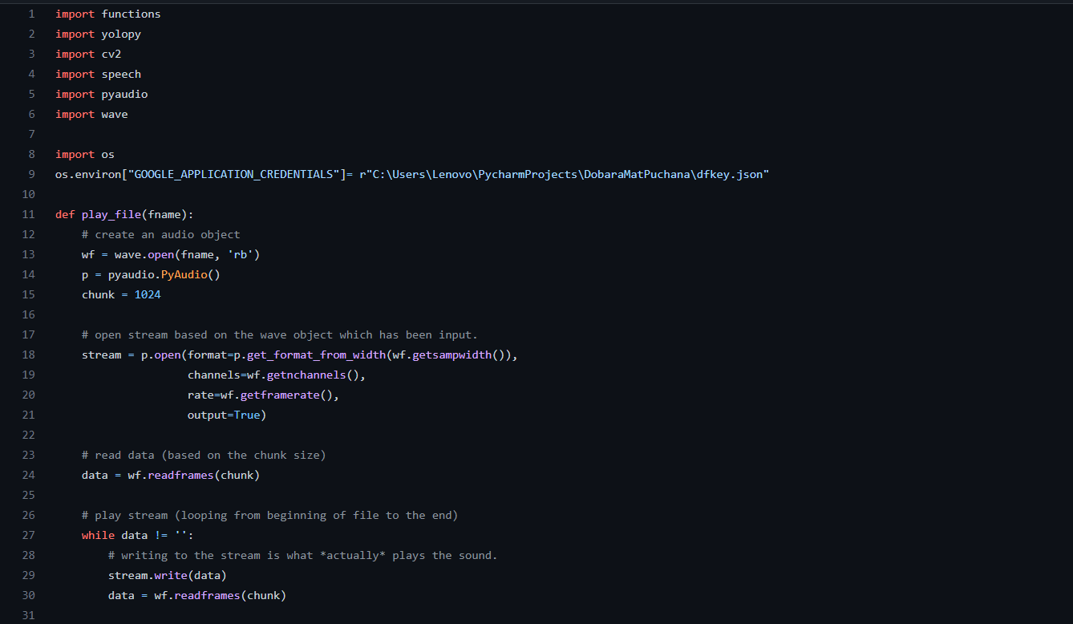

* 1. **SNAPSHOTS**

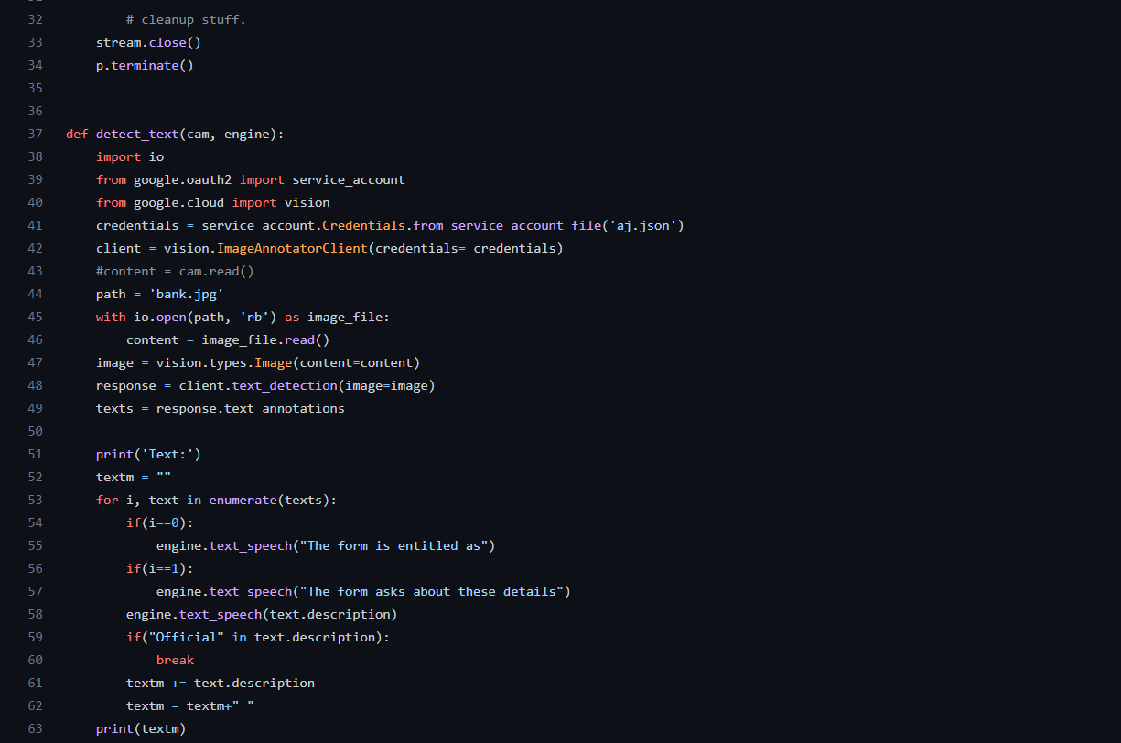

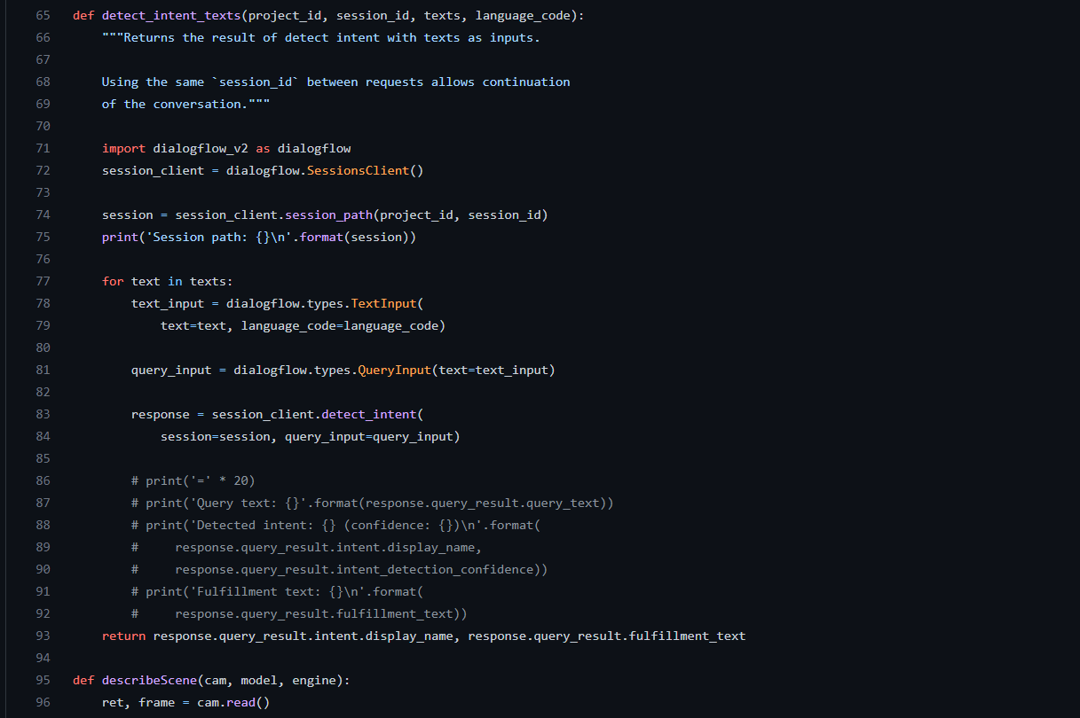

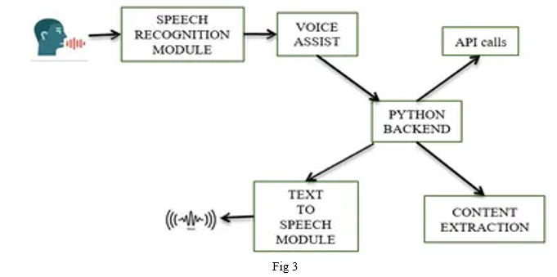

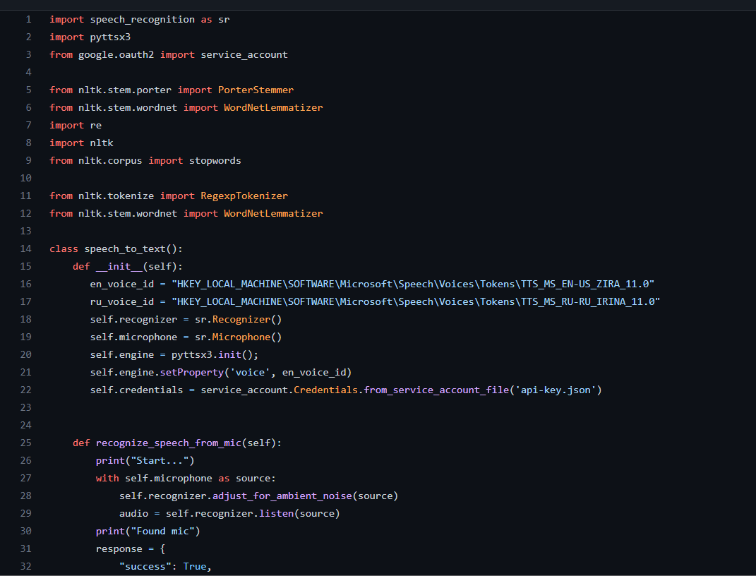

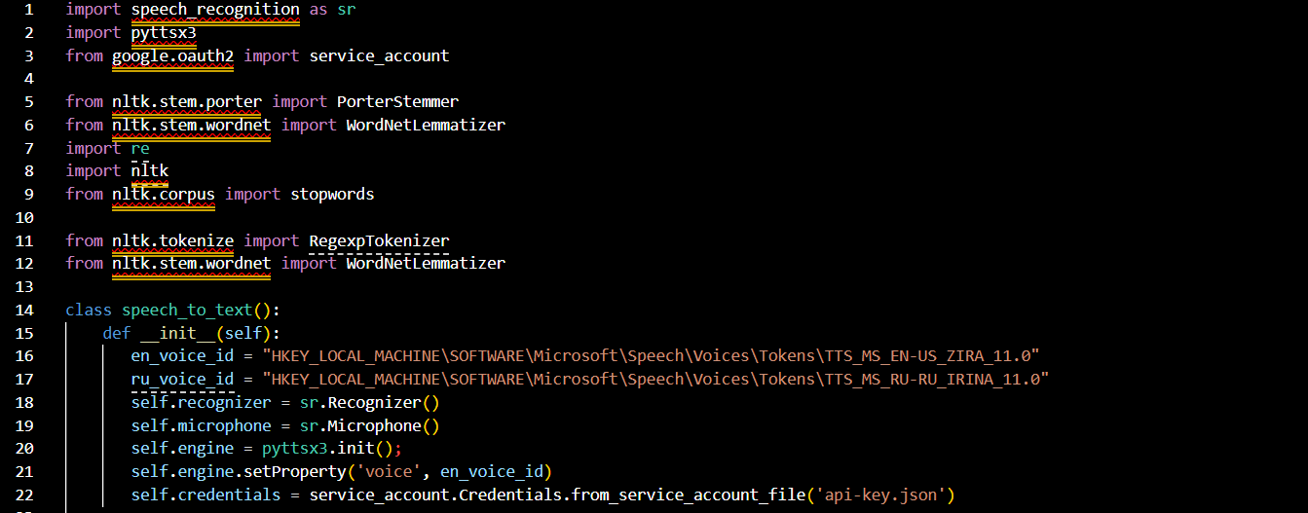

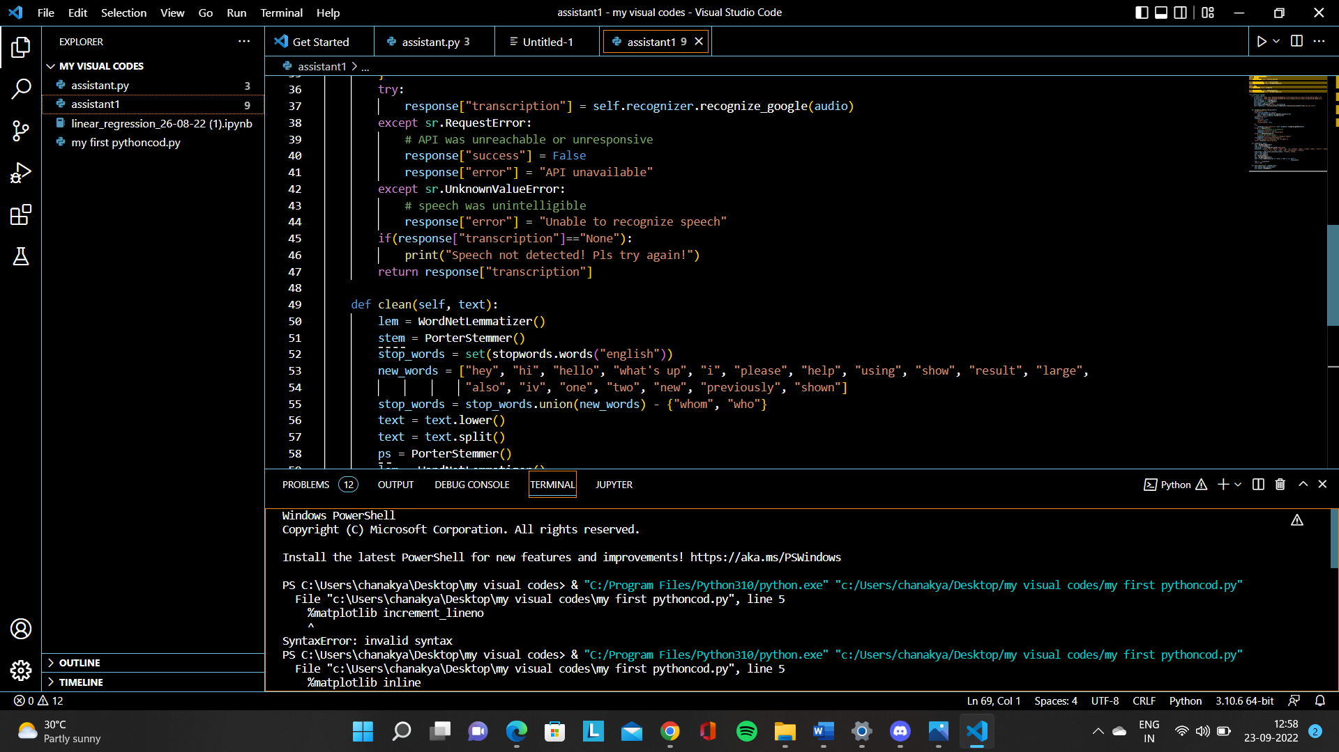

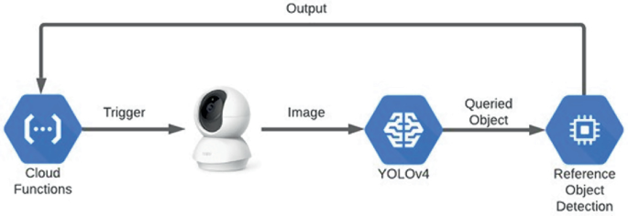

In this paper, the researchers proposed a voice assistant application for visually impaired individuals. The application will speak out every action performed by the users while accessing and using the customized important phone features. The system will provide voice assistance to individuals with vision impairment to perform daily basic tasks. The application was presented to target end-users for testing, checking, and evaluation. The result of the study showed that the developed system highly satisfied the needs and requirements of the intended users and respondents. The majority of the respondents have seen the potential of the application in assisting visually impaired individuals.

The researchers, therefore, concluded that the developed application will transform the assistance provided to visually impaired individuals. The said project will assist visually impaired individuals to perform day-to-day tasks through smart means. The voice assistant application will allow visually impaired users to do basic tasks using their phones without physical help and human interventions, only through

* 1. **CONCLUTION**

The package was designed in such a way that future modifications can be done easily. The following conclusions can be deduced from the development of the project:

* Automation of the entire system improves the efficiency
* It provides a friendly graphical user interface which proves to be better when compared to the existing system.
* It gives appropriate access to the authorized users depending on their permissions.
* It effectively overcomes the delay in communications.
* Updating of information becomes so easier
* System security, data security and reliability are the striking features.
* The System has adequate scope for modification in future if it is necessary.

# REFERENCE

https://github.com/radha2323/https-github.com-radha2323-Virtual-2-Assistant-for-Visually-impaired-.git